# 2.0 System Architecture

## 2.1 System Overview

The Lorbek Cars Showroom Online System is a comprehensive solution designed to revolutionize the management of car-related operations. This web-based platform offers users a seamless experience with advanced features, including robust search capabilities for cars, loans, bookings, and customers. Notably, all transactions are executed in offline mode, ensuring data security for car details, payment processing, and modifications. The system tracks and manages critical information such as payments, insurance, bookings, and customer data, providing a centralized hub for efficient resource management. Emphasizing user-friendliness, the interface validates fields to prevent the entry of invalid values, and it facilitates the generation of detailed reports on cars, payments, and insurance. Users can easily export data in various formats, including PDF, Excel, and CSV, enhancing accessibility and information sharing. With modules dedicated to administrative tasks, filtering reports, and user management, the system aims to overcome challenges inherent in manual processes, offering a secure, reliable, and error-free environment for Lorbek's Car Showroom operations.

## 2.2 System Architecture Overview

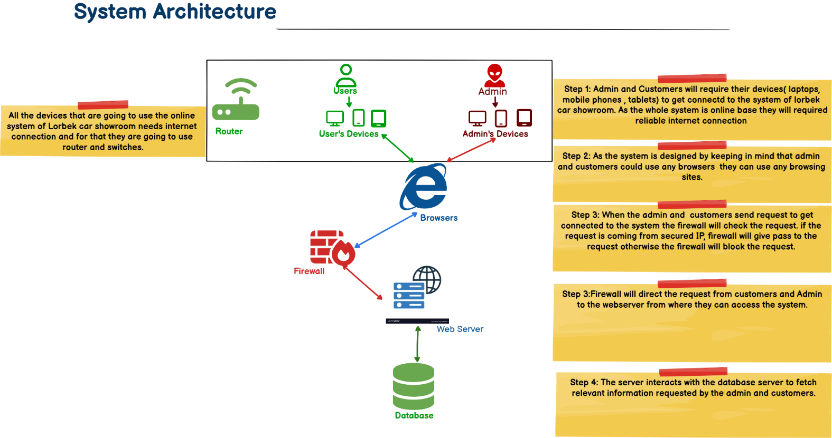

Fig 1: System Architecture

The system architecture of the Lorbek Cars Showroom Online System follows a streamlined process initiated by users accessing the platform through various hardware devices. Users, including both administrators and regular users, enter the system by typing the URL into their web browsers. The data exchange begins with a firewall ensuring secure communication, allowing authorized users to send and receive requests. These requests then reach the web server, responsible for processing them by retrieving and updating data from the database. The bidirectional arrows represent dynamic communication between the web server and the database, emphasizing the flow of information in both directions. This intricate but efficient architecture enables seamless interactions, ensuring that users can access and manage car-related operations securely and effectively through the Lorbek Cars Showroom Online System.

## 2.3 Hardware components

|  |  |  |
| --- | --- | --- |
| SN | Hardware Component | Description |
|  | Users Devices | These are the end-user devices through which administrators and regular users access the system. They require standard hardware specifications such as processors, memory, and display capabilities. |
|  | Firewalls | A dedicated hardware firewall device is essential for securing the network by monitoring and controlling incoming and outgoing traffic. It ensures that only authorized users and data can interact with the system. |
|  | Web server | The web server requires robust hardware resources to handle user requests, execute business logic, and generate dynamic web pages. Components include a powerful processor, sufficient RAM, storage for web applications, and a network interface for communication. |
|  | Database Server | The database server stores and manages the system's data. It requires high-performance hardware, including a powerful CPU, ample RAM for data retrieval, storage capacity for databases, and efficient data processing capabilities. |
|  | Routers and switches | Routers and switches facilitate communication between different hardware components within the network. Routers manage traffic between the internal network and the internet, while switches connect devices within the local network. |

## 2.4 Software components

Along with the hardware we have to make sure that all of the software that we are going to use in Lorbek online system are compatible with each other and they are latest too.

|  |  |  |
| --- | --- | --- |
| S.N | Software | Description |
|  | Operating system | Windows, Linux, MAC, Android, IOS |
|  | Web Server | Apache, MySQL for Hosting the System |
|  | Lucid chart | For showing Functional view of the system |
|  | Balsamic Cloud | Ui Wireframes |
|  | Dreamweaver | For writing and editing HTML, CSS, PHP codes. |